EXPERIMENT NO:
SIMULATION OF A SMART HOSPITAL LIVE PATIENT MONITORING SYSTEM USING PYTHON (GOOGLE COLAB)
Aim:
To develop and simulate a Smart Hospital Live Patient Monitoring System using Python in Google Colab that continuously generates and monitors the vital signs of multiple patients, displays the data in real time through live tables and graphs, automatically identifies emergency cases based on predefined medical thresholds, and provides instant emergency alerts.
Objective:
The objective of this experiment is to simulate a smart hospital patient monitoring system using Python in Google Colab. The system continuously monitors the vital signs of 25 patients by generating simulated values for body temperature, heart rate, and blood oxygen saturation (SpO₂) at regular intervals of five seconds. The monitored data are displayed in a live dashboard containing continuously updating tables and graphical visualizations for real-time observation. The system analyses each patient's health condition by comparing the generated values with predefined threshold limits and classifies them as either NORMAL or EMERGENCY. Whenever abnormal vital signs are detected, the system immediately displays an emergency alert along with the patient's details. This experiment demonstrates how live patient monitoring, automated health status classification, emergency detection, and real-time visualization can be implemented through simulation using Python in Google Colab.
Software Requirements:
- Google Colab
- Python 3.x
- Python Libraries Used
- pandas
- numpy
- matplotlib
- IPython.display
- random
- time
Theory:
A Smart Hospital Monitoring System continuously observes the health condition of patients by collecting their vital signs such as body temperature, heart rate, and oxygen saturation. In real hospitals, these values are obtained using medical sensors connected through IoT or IoE devices. Since physical hardware is not used in this experiment, the patient data are simulated using randomly generated values that resemble real medical readings.The system processes one patient every five seconds and updates the monitoring dashboard dynamically. After every update, the patient's vital signs are analysed against predefined threshold values. If any vital sign falls outside the normal range, the patient is classified as EMERGENCY; otherwise, the patient is considered NORMAL.
The generated information is displayed in a live table and continuously updated graphs, allowing healthcare staff to monitor patient conditions effectively. This simulation demonstrates the working principle of a real-time patient monitoring system without requiring physical medical devices.
Procedure:
- Start the program.
- Import all required Python libraries.
- Set the total number of patients to 25.
- Set the monitoring interval to 5 seconds.
- Create empty lists to store patient information.
- Generate random Temperature, Heart Rate, and SpO₂ values.
- Compare each patient's values with predefined threshold limits.
- Assign the patient status as NORMAL or EMERGENCY.
- Store the generated data.
- Display the live patient monitoring table.
- Display emergency patients separately.
- Update the live graphs.
- Wait for five seconds.
- Repeat until all 25 patients are monitored.
- Display "Monitoring Completed Successfully".
- Stop the program.
Threshold Values Used
Parameter | Normal Range | Emergency Condition
Temperature | 36.5°C – 37.5°C | >38°C or <35°C
Heart Rate | 60–100 BPM | <60 or >100 BPM
SpO₂ | 95–100% | <95%

Program Description
The Python program simulates a smart hospital environment where 25 patients are monitored one after another. For every patient, the system generates body temperature, heart rate, and SpO₂ values. These values are stored in a DataFrame and displayed in a live monitoring table. Simultaneously, the system updates graphical charts representing the patient's health parameters. Based on predefined threshold values, each patient is automatically classified as either NORMAL or EMERGENCY. Whenever an emergency patient is detected, an alert message and the patient's details are immediately displayed. The simulation continues until all patients have been monitored.
# SMART HOSPITAL LIVE PATIENT MONITORING SYSTEM
import random
import time
import pandas as pd
import matplotlib.pyplot as plt
from IPython.display import clear_output, display
# SETTINGS
TOTAL_PATIENTS = 25 # Total number of patients
UPDATE_INTERVAL = 5 # Seconds between patients
# STORAGE LISTS
patient_ids = []
temperatures = []
heart_rates = []
spo2_values = []
status_list = []
time_axis = []
# FUNCTION TO GENERATE PATIENT DATA
def generate_patient():
temperature = round(random.uniform(35.5, 40.5), 1)
heart_rate = random.randint(60, 120)
spo2 = random.randint(88, 100)
if temperature >= 38 or heart_rate > 100 or spo2 < 95:
status = "EMERGENCY"
else:
status = "NORMAL"
return temperature, heart_rate, spo2, status
# LIVE GRAPH FUNCTION
def live_graph():
plt.figure(figsize=(12,6))
plt.plot(time_axis, temperatures, marker='o', linewidth=2, label="Temperature (°C)")
plt.plot(time_axis, heart_rates, marker='s', linewidth=2, label="Heart Rate (BPM)")
plt.plot(time_axis, spo2_values, marker='^', linewidth=2, label="SpO₂ (%)")
plt.title("Smart Hospital Live Monitoring")
plt.xlabel("Patient Number")
plt.ylabel("Reading")
plt.grid(True)
plt.legend()
plt.show()
# LIVE MONITORING LOOP
for patient in range(1, TOTAL_PATIENTS + 1):
temperature, heart_rate, spo2, status = generate_patient()
patient_ids.append(f"P{patient:02d}")
temperatures.append(temperature)
heart_rates.append(heart_rate)
spo2_values.append(spo2)
status_list.append(status)
time_axis.append(patient)
df = pd.DataFrame({
"Patient": patient_ids,
"Temperature (°C)": temperatures,
"Heart Rate (BPM)": heart_rates,
"SpO₂ (%)": spo2_values,
"Status": status_list
})
clear_output(wait=True)
print("=" * 70)
print(" SMART HOSPITAL LIVE PATIENT MONITORING ")
print("=" * 70)
print(f"Patients Processed : {patient}/{TOTAL_PATIENTS}")
print(f"Elapsed Time : {(patient-1)*UPDATE_INTERVAL} seconds\n")
display(df)
emergency = df[df["Status"] == "EMERGENCY"]
print("\nNormal Patients :", len(df) - len(emergency))
print("Emergency Patients :", len(emergency))
if len(emergency) > 0:
print("\n🚨 EMERGENCY ALERT 🚨")
display(emergency)
live_graph()
if patient != TOTAL_PATIENTS:
time.sleep(UPDATE_INTERVAL)
# FINAL REPORT
print("\n")
print("=" * 70)
print("MONITORING COMPLETED SUCCESSFULLY")
print("=" * 70)
final_df = pd.DataFrame({
"Patient": patient_ids,
"Temperature (°C)": temperatures,
"Heart Rate (BPM)": heart_rates,
"SpO₂ (%)": spo2_values,
"Status": status_list
})
display(final_df)
final_df.to_csv("Smart_Hospital_Report.csv", index=False)
print("\nCSV file saved as Smart_Hospital_Report.csv")
Input
Total Patients = 25
Monitoring Interval = 5 seconds
Simulated Temperature
Simulated Heart Rate
Simulated SpO₂
Output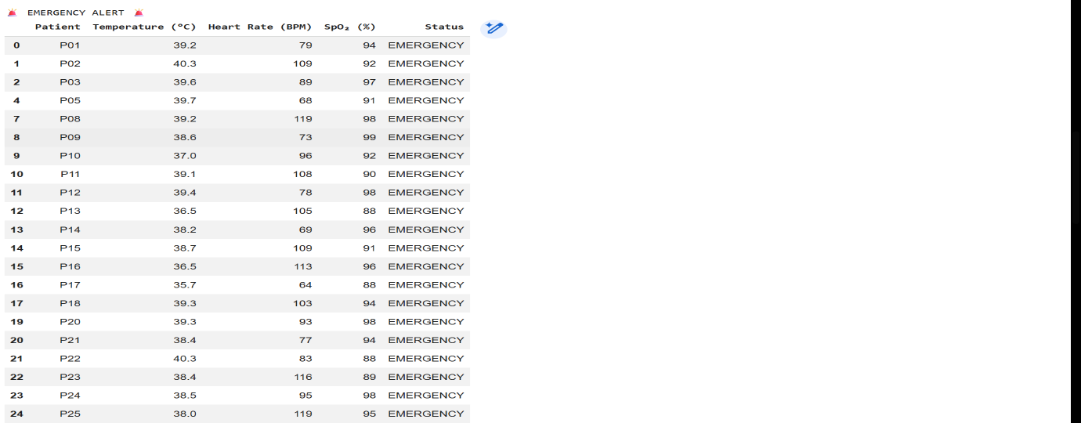
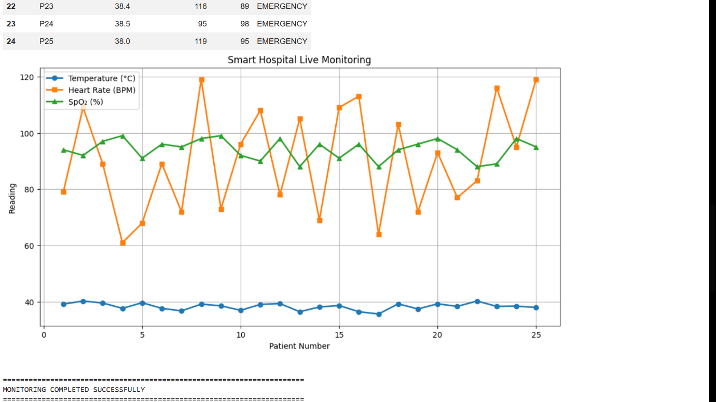
Observations
- Patient vital signs are generated every five seconds.
- The monitoring table updates automatically after each patient.
- Graphs display real-time changes in Temperature, Heart Rate, and SpO₂.
- Patients exceeding threshold limits are classified as EMERGENCY.
- Emergency alerts are displayed immediately.
- The simulation successfully monitors all 25 patients.
Applications
- Smart hospitals
- Patient monitoring systems
- Intensive Care Units (ICU)
- Telemedicine
- Remote healthcare monitoring
- Medical training and simulation
- Healthcare data visualization
- IoT-based healthcare research
Result:
The Smart Hospital Live Patient Monitoring System was successfully simulated using Python in Google Colab. The system monitored 25 simulated patients by generating body temperature, heart rate, and SpO₂ values at five-second intervals. The patient information was displayed through a live monitoring table and continuously updated graphs. The system accurately classified patients as NORMAL or EMERGENCY based on predefined threshold values and displayed emergency alerts whenever abnormal conditions were detected. Thus, the experiment successfully demonstrated real-time patient monitoring, live data visualization, automated health status classification, and emergency detection in a simulated smart healthcare environment

